

UNIVERSITY OF HERTFORDSHIRE
School of Physics, Engineering and Computer Science

Comparative Evaluation of Workforce Forecasting Models for E-Commerce Fulfilment Centre Operations Using a Spring Boot Analytics Platform

MSc Cyber Security
7COM1039-0509-2025
Advanced Computer Science Masters Project
02nd June 2026
MSc Cyber Security
7COM1039-0509-2025
Advanced Computer Science Masters Project
02nd June 2026
Table of Contents
CHAPTER I – INTRODUCTION & OVERVIEW 2
1.1 Background 2
1.2 Problem Statement 3
1.3 Research Aim 3
1.4 Research Objectives 3
1.5 Research Questions 3
1.6 Project Scope 4
1.7 Tools and Technologies 4
CHAPTER II – PROGRESS TO DATE 4
2.1 Literature Review Progress 4
2.2 Prototype Design Progress 5
2.4 Preliminary Results 6
CHAPTER III – PLANNED WORK 6
3.1 Remaining Tasks 6
3.2 Project Timeline 6
3.3 Risk Management and Contingency Planning 6
Bibliography 7

CHAPTER I – INTRODUCTION & OVERVIEW

1.1 Background
Workforce planning is a critical operational activity within modern e-commerce fulfilment centres. Organisations operating large-scale warehousing and distribution facilities must continuously balance workforce availability against fluctuating customer demand. Seasonal sales events, promotional campaigns, holidays, and unexpected changes in consumer purchasing behaviour can significantly impact staffing requirements.
Traditional workforce planning methods often depend on manual estimation, historical observations, and spreadsheet-based calculations. While these approaches may provide basic planning support, they frequently struggle to respond effectively to dynamic operational environments. Inaccurate workforce planning can result in understaffing, overstaffing, increased labour costs, reduced productivity, delayed order fulfilment, and lower customer satisfaction.
Recent developments in predictive analytics, machine learning, and artificial intelligence have enabled organisations to adopt data-driven approaches to workforce forecasting. Advanced forecasting models can analyse historical workforce and operational data to predict future staffing requirements more accurately than traditional methods. These techniques allow organisations to make informed workforce planning decisions while improving operational efficiency and resource utilisation.
This project investigates the application of workforce forecasting techniques within an e-commerce fulfilment centre environment and develops a software platform capable of supporting workforce planning through analytical dashboards, forecasting models, and performance evaluation capabilities.

1.2 Problem Statement
Many fulfilment centres continue to rely on traditional workforce planning approaches that are heavily dependent on manual intervention and historical trend analysis. These methods often fail to accommodate rapidly changing operational conditions and may lead to inaccurate workforce allocation decisions.
Although numerous forecasting techniques have been proposed within the literature, limited research has focused on comparative evaluation of workforce forecasting models specifically within fulfilment centre operations. Furthermore, many existing studies primarily focus on forecasting accuracy while providing limited consideration of practical implementation through operational analytics platforms.
There is therefore a need for a comprehensive evaluation of forecasting approaches combined with a practical software solution capable of supporting workforce planning and operational decision-making.

1.3 Research Aim
The aim of this research is to implement, compare, and evaluate workforce forecasting approaches within an e-commerce fulfilment centre environment and determine the most effective forecasting method for supporting workforce planning and operational decision-making through a Spring Boot analytics platform.

1.4 Research Objectives
The objectives of this project are:
- To investigate workforce planning and capacity management practices used within e-commerce fulfilment centres.
- To review forecasting techniques commonly applied to workforce demand prediction.
- To identify operational metrics that influence workforce planning effectiveness.
- To develop a Spring Boot-based workforce analytics platform.
- To implement selected statistical, machine learning, and deep learning forecasting models.
- To evaluate forecasting approaches using established performance metrics.
- To compare forecasting techniques and identify the most effective approach.
- To provide recommendations for workforce planning improvement.

1.5 Research Questions
The project seeks to answer the following research questions:
- How do different workforce forecasting approaches perform within fulfilment centre operations?
- Which forecasting technique provides the highest prediction accuracy?
- What operational factors have the greatest influence on workforce planning effectiveness?
- How effectively can forecasting models support workforce planning decisions?
- Which forecasting approach provides the best balance between prediction accuracy, implementation complexity, and operational usefulness?

1.6 Project Scope
The project focuses on workforce demand forecasting within e-commerce fulfilment centre operations. The scope includes the collection and preparation of workforce-related datasets, implementation of forecasting models, development of a workforce analytics platform, and evaluation of forecasting performance.
The system is designed as a research and decision-support platform rather than a full workforce management system. Features include forecasting execution, workforce monitoring, dashboard visualisation, performance comparison, capacity planning, reporting, and analytics.

1.7 Tools and Technologies
Backend Technologies
- Java 21
- Spring Boot
- Spring Data JPA
- Maven
Frontend Technologies
- Vue.js 3
- PrimeVue
- Chart.js
- TypeScript
Database Technologies
- MySQL
Forecasting Technologies
- Prophet
- LSTM
- XGBoost
- Random Forest
- Linear Regression
Development Tools
- IntelliJ IDEA
- Visual Studio Code
- GitHub

CHAPTER II – PROGRESS TO DATE

2.1 Literature Review Progress
A substantial literature review has been completed focusing on workforce planning, operational analytics, forecasting techniques, machine learning, and decision-support systems.
The review examined both traditional forecasting approaches and modern machine learning techniques. Research findings indicate that forecasting accuracy varies significantly depending on dataset characteristics and operational environments.
The literature review also identified a research gap concerning comparative evaluation of forecasting approaches within fulfilment centre operations while integrating results into operational analytics platforms.

2.2 Prototype Design Progress
Significant progress has been made in the development of the Workforce AI Analytics Platform. The Spring Boot backend architecture and Vue.js frontend framework have been successfully established. A modular user interface has been developed consisting of Dashboard, Forecasting, Shift Optimisation, Employees, Analytics, Capacity Planning, Monitoring, Benchmarks, Reports, Notifications, and Settings modules.
The Dashboard module provides workforce KPIs, operational alerts, forecasting visualisations, and performance metrics. In addition, the Settings module has been implemented to support future configuration of forecasting, analytics, and reporting features. The current prototype demonstrates the overall system architecture and provides a strong foundation for integrating forecasting models during the next development phase.
Backend
- Spring Boot project setup
- Application architecture design
- API framework creation
- Database configuration
Frontend
- Vue.js application setup
- PrimeVue integration
- Responsive design implementation
- Routing and navigation
Modules Developed
- Dashboard
- Forecasting
- Shift Optimization
- Employees
- Analytics
- Capacity Planning
- Monitoring
- Benchmarks
- Reports
- Notifications
- Settings
Dashboard Features
- Workforce KPI Cards
- Forecast Accuracy Monitoring
- Capacity Utilisation Tracking
- Operational Alerts
- Workforce Demand Visualisation
- Search Functionality
- Real-time Dashboard Layout
The current prototype demonstrates the overall system architecture and establishes the foundation for future forecasting integration.

2.4 Preliminary Results
Initial testing has confirmed the successful operation of the platform architecture, navigation system, dashboard components, and visualisation features. Interactive charts, KPI cards, and data presentation components have been implemented and tested successfully.
Although forecasting models have not yet been integrated, the completed software prototype demonstrates the feasibility of the proposed solution and confirms that the selected technology stack can support future forecasting and workforce planning functionality.
Current testing confirms successful operation of (as of now these data is dummy):
- Frontend navigation
- Dashboard rendering
- Chart visualisation
- Data tables
- Responsive design
- Component integration
The developed prototype demonstrates the feasibility of the proposed analytics platform.

CHAPTER III – PLANNED WORK

3.1 Remaining Tasks
- Dataset acquisition
- Dataset preparation
- EDA implementation
- Prophet implementation
- XGBoost implementation
- Random Forest implementation
- LSTM implementation
- Forecasting evaluation
- Comparative analysis
- Dissertation writing

3.2 Project Timeline
Activity | Target Completion
Dataset Preparation | June
Forecasting Models | June–July
Comparative Evaluation | July
Testing | July
Dissertation Writing | July–August
Final Submission | August

3.3 Risk Management and Contingency Planning
Potential risks include:
- Dataset limitations
- Model underperformance
- Development delays

Bibliography
Chopra, S. and Meindl, P. (2019) Supply Chain Management: Strategy, Planning and Operation. 7th edn. Pearson Education.
Hyndman, R.J. and Athanasopoulos, G. (2021) Forecasting: Principles and Practice. 3rd edn. Available at: https://otexts.com/fpp3/ (Accessed: 15 June 2026).
Waller, M.A. and Fawcett, S.E. (2013) 'Data Science, Predictive Analytics, and Big Data: A Revolution That Will Transform Supply Chain Design and Management', Journal of Business Logistics, 34(2), pp. 77–84.
Box, G.E.P., Jenkins, G.M., Reinsel, G.C. and Ljung, G.M. (2015) Time Series Analysis: Forecasting and Control. 5th edn. Wiley.
Brownlee, J. (2018) Deep Learning for Time Series Forecasting. Machine Learning Mastery.
Goodfellow, I., Bengio, Y. and Courville, A. (2016) Deep Learning. MIT Press.
Pedregosa, F. et al. (2011) 'Scikit-learn: Machine Learning in Python', Journal of Machine Learning Research, 12, pp. 2825–2830.
Taylor, S.J. and Letham, B. (2018) 'Forecasting at Scale', The American Statistician, 72(1), pp. 37–45.

Appendices
Appendix A – System Architecture
The proposed Workforce AI Analytics Platform follows a three-tier architecture consisting of a Vue.js frontend, Spring Boot backend, and MySQL database. The architecture is designed to support workforce forecasting, analytics, reporting, and workforce planning activities.

Appendix B – Dashboard Screenshots
Figure B1: Workforce AI Operations Command Centre Dashboard

The dashboard displays workforce KPIs, forecasting metrics, workforce demand visualisations, operational alerts, and system performance indicators.
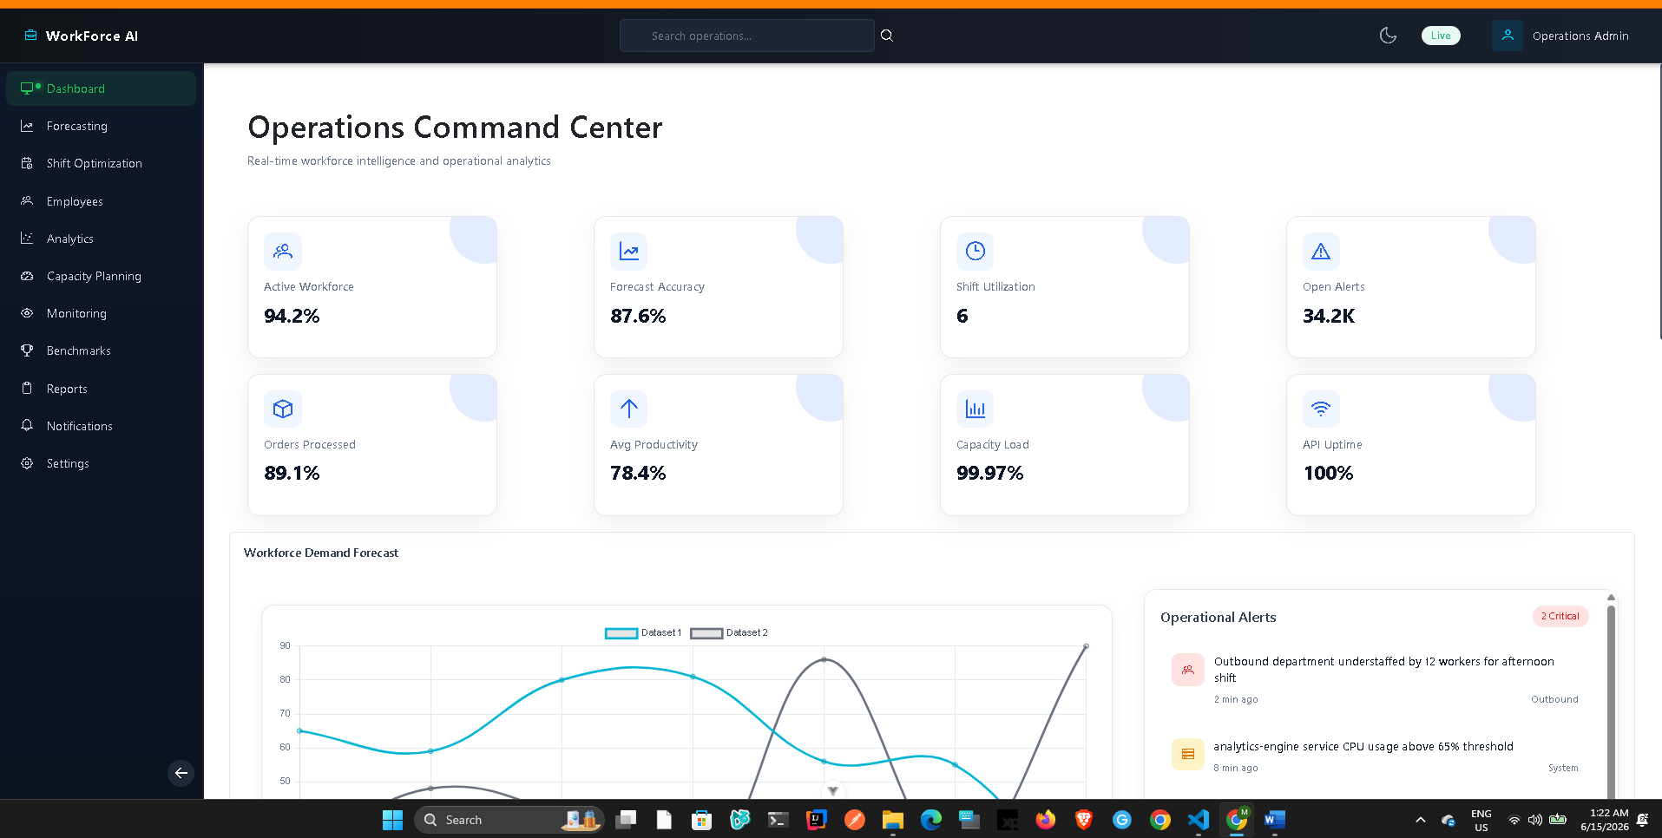

Appendix C – Settings Module Screenshots
Figure C1: Settings Management Module
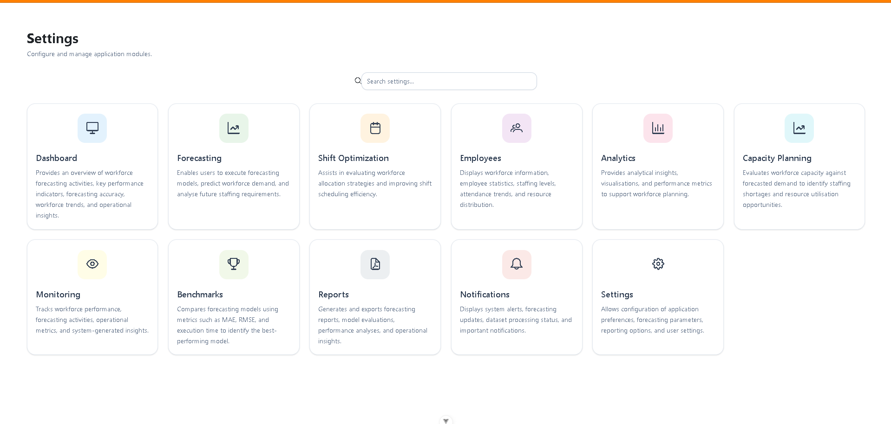

The Settings module provides configuration options for forecasting, analytics, capacity planning, reporting, monitoring, and workforce management features.

Appendix D – Development Evidence
Completed development activities include:
- Spring Boot project setup
- Vue.js application setup
- PrimeVue integration
- Dashboard implementation
- Navigation framework
- Responsive UI design
- Settings module development
- Chart visualisations
- KPI card implementation
- API integration framework

Appendix E – Project Timeline
Activity | Status
Backend Development | In Progress
Literature Review | Completed
Project Setup | Completed
Frontend Development | In Progress
Dataset Preparation | Planned
Forecasting Model Development | Planned
Comparative Evaluation | Planned
Testing and Validation | Planned
Dissertation Writing | Planned
Dataset Preparation | Planned
Forecasting Model Development | Planned

